

iSERV Interim Report

December 2012

By

Ian Knight and Afroditi Maria Konidari

Intelligent Energy – Europe (IEE) SAVE Project

May 7th 2011 to May 6th 2014

Project websites:

Main website: <http://www.iservcmb.info>

Database website: <http://www.iservcmb.eu>

**iSERV Project Team**

|  |  |  |  |
| --- | --- | --- | --- |
| Welsh School of Architecture, Cardiff University  UK (Project co-ordinator) | cardiffuniversitylogo | K2n Ltd  UK | K2n logo |
| MacWhirter Ltd  UK | Macs Logo | National and Kapodistrian University of Athens  Greece | logo |
| University of Porto  Portugal | logo_UP_FEUP_cor | Politecnico di Torino  Italy | marchio_blu_200x200_b |
| Université de Liège  Belgium | logo_coul_texte_blason_cadre_300 | Univerza v Ljubljani  Slovenia | UNI-logo in FS-color-ANG-curve |
| University of Pecs  Hungary | PTE logo 1 | Austrian Energy Agency  Austria |  |
| REHVA  EU | REHVAlogo_name_300dpi | CIBSE  UK | CIBSE sustain colour logo RGBweb |

# WP1: D9.3 -European project website (in English, for the purpose of European-wide dissemination)

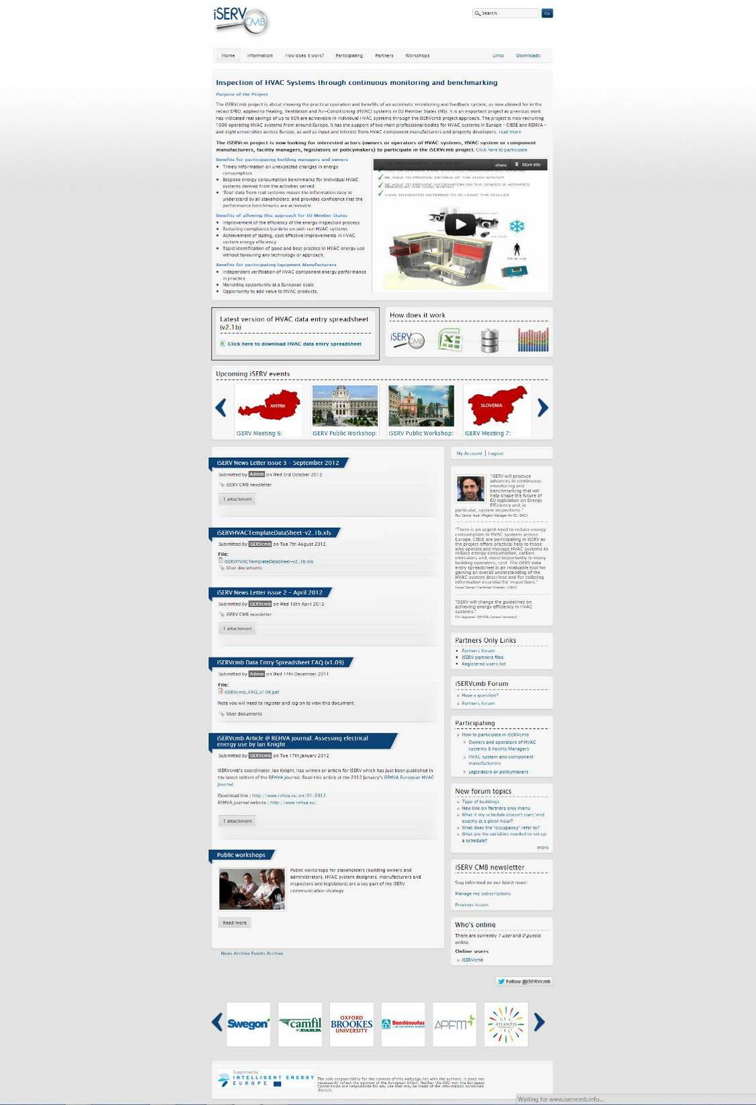

# Overview of iSERV website traffic during the project’s life

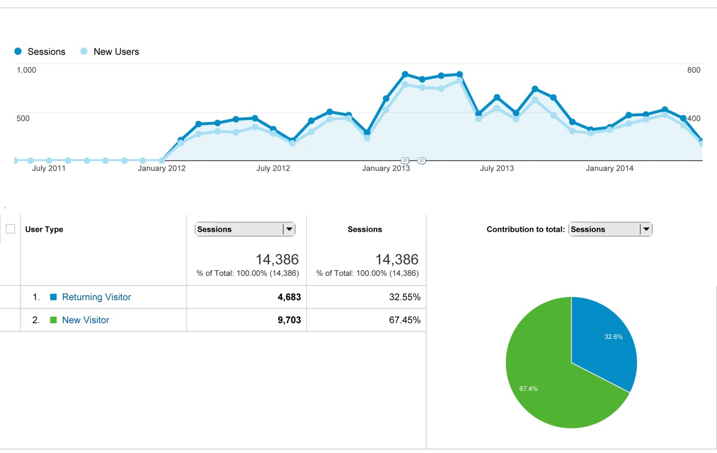

\*A session is the period time a user is **actively** **engaged** with the website.

\*\* New users: The number of first-time users.

# Overview of iSERV website demographics during the project’s life

